CHEMICAL ENGINEERING TRANSACTIONS  VOL. , 2023 | A publication of
The Italian Association
of Chemical Engineering
Online at www.cetjournal.it

Guest Editors: Laura Piazza, Mauro Moresi, Francesco Donsì
Copyright © 2023, AIDIC Servizi S.r.l.
ISBN 979-12-81206-01-4; ISSN 2283-9216

Obtaining a vodka-like distillate from a native Colombian yam (Dioscorea spp.)
Marco Masonª, Katherine Ramírez Carvajalª, Clara Isabel Sánchez Bernalª, Juan Camilo Mendoza Combatª, Jason Donald Kenealey^{b}, Laura Patricia Acosta Garcia^{c}, Martha María Cuenca Quicazan^{c}
ª Universidad Nacional Abierta y a Distancia (UNAD) - Cl. 14 Sur # 14-23, Bogotá D.C., Colombia (CO)
^{b} Brigham Young University (BYU), Provo, UT 84602, United States (US)
^{c} Universidad de Cartagena, Avenida del Consulado, Calle 30 # 48-152, Cartagena de Indias, Bolívar, Colombia (CO) mcuencaq@unicartagena.edu.co
Yam is currently an emblematic tuber from Colombian Caribbean Region. Its cultivation and consumption are linked to the arrival of slaves on the Caribbean Coast. Colombia’s yam has stood out worldwide for its technological advances in cultivation and it has been among the countries with the best performance indicators in tons per hectare planted. The 90% of the national production comes from Caribbean Region. However, the high perishability of the yam, and high temperatures, the lack of communication routes and the high transportation costs, increase the losses and limit the profitability of the product. There is an overproduction of yam and other tubers too. The impact has come to significantly impoverish both farmers and consumers, even affecting the presence of yam in local population diet.
Under similar circumstances, in many cultures distilled alcoholic beverages have emerged from local foods, such as wheat, malt, potato, sugar cane, grapes, etc. The aim of this article is to show preliminary results about using yam as a raw material in an alternative way. It could contribute to increase yam’s value through developing a vodka-like distilled process. In this case, raw yam flour was hydrolyzed to obtain a worth to be fermented at 20°C with a commercial S. cerevisiae yeast. After fermentation a simple batch distillation in a copper distiller was made. During the process, it was measured temperature, fermentation time, pH, and Brix degree. All transformation process was done in a pilot plant (CE 640 Gunt, Hamburg). A first-order kinetics model was adjusted to sugars consumption, and a Gompertz model was used to ethanol production. It is concluded that an alcoholic beverage based on yam can be an alternative to yam overproduction.

Keywords / Keywords
Yam, fermented beverages, distilled beverages, physicochemical analysis, kinetics

  - Introduction
The yam is a tropical plant, from Africa and Asia origin (Mignouna et al., 2014) it is a monocotyledonous, it belongs to the Dioscoreaceae family, and it has a reserve organ that is a tuber. It has six genera, including Dioscorea spp., which is the most important with 600 identified species, although only 12 species are edible (Hurtado, 2000) and vary depending on the variety. The most cultivated genera in Colombia in the Caribbean Region are D. bulbifera or Creole yam, D. rotundata or Espino yam, and Diamond yam (D. alata). San Cayetano is a village located in the municipality of San Juan Nepomuceno (Bolívar), in the sub-region of Montes de María in northern Colombia Caribbean Region produces the most of yam of the country. This tuber has a high nutritional value for urban and rural populations. It contains carbohydrates, minerals such as calcium, iron and phosphorus, certain levels of vitamins A and C, as well as vitamin B1 and vitamin B5. It also contains riboflavin, niacin, ascorbic acid, pyridoxine and carotenes (Gonzalez, 2012). This food has a starch content like corn; therefore, food industries use yam starch as a corn starch alternative. So, for this reason is an appreciated tuber in many countries (Espitia, J., Salcedo, J., & Garcia, 2016) (D. Polycarp; E. O. Afoakwa; A. S. Budu; E. Otoo, 2012). Within the tuber crops, the yam production system can be considered important due to its contribution to food safety. It presents a high diversification potential to produce starch, alcohols, pharmaceutical products (Maria de los Angeles Fernandez Haeckermann, Leonardo & Gutiérrez, 2012) related to the extraction and use of derivatives of diosgenin (González Vega, 2012), biopolymers from starch (Tejeda Benítez et al., 2008) and biofuels (Pradyawong et al., 2018) (Alvis et al., 2008).
Companies that are selling large quantities of yam are only about five, while close to 30,000 families of small and medium farmers manage relatively small quantities. Yam is a fundamental part of their diet, it is the main source of income and rural employment, but due to logistical inconveniences, they can only sell it during yam’s shelf-life. There are many losses that the farmer must assume during 2021 and they have had an overproduction. Until now, there is not a clear possibility to add value; products obtained by the transformation induced by the same farmer do not stand out in the market.
The aim of this article is to show an alternative use of yam, which allows generating value through a vodka-like distilled process. All experiments were performed in a pilot plant (CE 640 Gunt, Hamburg). Enzymatic hydrolysis was used to convert starch into fermentable sugars (yam flour and potato starch). An alcoholic fermentation (20 °C with a commercial S. cerevisiae yeast) was performed as well as a simple batch distillation in a copper distiller. Temperature, fermentation time, pH, and Brix degree were measured during the process. Sugars consumption and ethanol production were modelled by using kinetics models (first order and Gompertz).
  - Materials and methods
    - Materials
Yam flour was bought from the gastronomic association of afro-yam from San Cayetano (Bolívar, Colombia), that is a group of women yam and cassava flour producers. Tap water was used directly from the aqueduct of Bogotá, Colombia. Thermostable Alpha-amylase and glucoamylase from LD Carlson Company (Kent, OH) were used to performed starch hydrolysis. Alpha-amylase was a thermostable powdered enzyme used for long-chain yam starch hydrolysis into dextrin, with an optimum activity at 85-95°C and an optimum pH at 6 to 6.5. This enzyme is stable up to 110°C. The dose was and it was the producer recommended (0.060 g/l). Glucoamylase was a powdered enzyme used for the hydrolysis of short-chain dextrin into fermentable sugars. It was used as the producer recommended dose (0.060 g/l), with an optimal temperature of 55-60°C and an optimum pH of 4 to 4.5. It was used a commercial yeast (SafBrew HA-18 Fermentis by Lesaffre, Marcq-en-Baroeul Cedex, France) and a dose of 1,6 g/l. Fermentation was performed during 7 days at 20 °C.
    - Methods
Methods and equipment used for obtaining the yam distillate.
Yam flour characterization
Yam flour was obtained by producers by sun drying and milling dried tuber. Its composition was analyzed and the results are shown in Table 1.
Table 1: Composition of yam flour
Parameters | Methods | Results | Units
Moisture | Gravimetry – Dried in hoven a 105°C | 12.9 | g/100g
Total solid | AOAC 925.10. Ed 21:2019 (Gravimetry) | 87.1 | g/100g
Total carbohydrates | Calculated by difference | 81.8 | g/100g
Total protein | ISO 1871:2009 (Kjeldahl) | 3.3 | g/100g
Total fat | (Soxhlet ethereal extraction) | 0.3 | g/100g
Total fiber | (Hydrolysis acid, alkaline and calcination) | 0.6 | g/100g
Ash | (Gravimetry - calcination at 600°C) | 1.7 | g/100g

Moisture and Total Solid
Moisture was determined by the oven drying method (AOAC 930.15, 2000), sample was place in the oven for 2.5 hours at 105 °C ± 2 °C and then cool in the desiccator for 30 min and then weight in a balance with a precision of 0.1 mg. Moisture and total solids contents of foods can be calculated as follows using oven drying procedures: with the Eq(1) and Eq(2) (Nielsen, 2007):
$\% Moisture \left(wt/wt\right)=\frac{wt water in sample }{wt of wet sample }x 100$ | (1)
$\% Total solids \left(wt/wt\right)=\frac{wt of dry sample }{wt of wet sample }x 100$ | (2)
Total protein
The Kjeldahl procedure (AOAC 955.04) was used for the determination of total protein in the yam flour. (Nielsen, 2007)

Total fat
The Soxhlet method (AOAC Method 920.39C for Cereal Fat) was used for the determination of the total fat in the yam flour. (Nielsen, 2007)

Total dietary fiber
Total dietary fiber (AOAC Method 991.43a) can be calculated as the sum of the insoluble and soluble dietary fiber. (Nielsen, 2007)

Ash
The ash content was determinate by gravimetry after calcination in muffle at 600 °C.

Soluble solids content
The refractometer was used to determinate the soluble solids content in a rapid and accurate way (AOAC Method 9.32.14C, for solids in syrups). (Nielsen, 2007)

Enzymatic hydrolysis and gelatinization process
All processing steps were performed in the Gunt CE 640 pilot plant located at Open and Distance University (UNAD), Bogotá, Colombia. This pilot plant has three main components: a mash tank, a fermentation tank, and a distillation unit. A scheme of the plant was shows in a Figure 1.

Figure 1: Schematic representation of pilot plant CE 640 Gunt, used to produce the yam distillate. The main part are: 1) Cooling water control valve, 2) acid/caustic tanks 3) acid/caustic pump, 4) spent mash tank (mobile), 5) distillation unit, 6) product tank, 7) switch cabinet, 8) condenser, 9) fermentation tank, 10) mash tank, 11) steam pressure control valve (Bieschke, 2013)

The mash tank is used for the liquefaction/saccharification which is equipped with a double jacket, the temperature was determined through a temperature sensor integrated in the bottom. In addition there is a pH measurement probe for its regulation (Bieschke, 2013).
40 liters of tap water, 1.978 kg of yam flour and 1.714 kg of potato starch were added. Previously, yam flour and potato starch were mixed in 5 L of cold water to solve them. 7.228 g of Alpha-amylase were added at 90 °C for 2 hours at a pH of 5.4. Gelatinization stage was necessary for the enzymatic hydrolysis and was caused for the injection of the heating steam from a nozzle, the temperature of the gelatinization is from 75 to 79 °C depends on the variety of yam (Alvis et al., 2008). During this step, viscosity of the wort was reduced. This is fundamental for the safety of the pump installed in the pilot plant and this also indicate a good progress of the process. 7.246 g of Glucoamylase was then added at 60 °C for 2 hours at pH 5.2.

Fermentation
After starch enzymatic hydrolysis, the wort was passed into the fermentation tank. It was hermetically closed, and temperature was controlled. Fermentation tank is also equipped with a stirring mechanism and a temperature sensor (Bieschke, 2013). To start fermentation, 56 g of yeast (Saccharomyces cerevisiae), SafBrew HA-18 (Fermentis by Lesaffre) was activated in a small volume of the wort, and then it was added to the fermentation tank containing the fermentable sugars obtained before. It was added 40 g of malt extract. Fermentation was performed at 20 °C without stirring, for 7 days.

Distillation
Distillation unit is equipped with a distillation column with 6 bell plates for ethanol separation, and two vessels for the separated ethanol and the stillage produced, respectively. Heating was carried out with an internal electrical resistance (Bieschke, 2013). Atmospheric pressure in Bogotá, which is located at 2,600 m.a.s.l, is 74,66 kPa. For this reason, methanol has its boiling point 55-60 ºC, and ethanol around 70-75 ºC. (Lawrence S. Brown, 2018). Ethanol concentration was measured by using an alcoholmeter.

Ethanol content
Alcoholometers were used to estimate the alcohol content of alcoholic beverages. Such hydrometers are calibrated at 20°C proof to determine the percentage of alcohol in distilled liquors (AOAC Method 957.03).(Nielsen, 2007)

Glucose consumption model
According to (Cano Triana, 2020; Cuenca et al., 2022), during alcoholic fermentation it can be considered that glucose consumption can be considered to follow the first order kinetic model, which is presented in Eq(3). This equation was linearized (ln), to find the glucose consumption rate constant (k), generating Eq(4).

$\frac{{dC}_{glucose}}{dt}=-k*C_{glucose}$(3)

$lnC_{glucose}=ln{(C}_{glucose }(t_{o }))-k*t$ (4)
Ethanol production model
In case of ethanol formation, which depends on the glucose consumed and on the stoichiometry of the fermentation equation (1 mol of glucose produce 2 mol of ethanol), it is reported that it can follow the Gompertz model (Cano Triana, 2020; Cuenca et al., 2022). The Gompertz model consists of a function with a double exponential and three parameters of fit, which describes an asymmetric sigmoidal curve, as presented in Eq(5).

$y= a* e^{-e^{- k\left(t-c\right)}}$(5)

where a is the maximum potential value of the response variable y when the independent variable time (t) tends to infinity, c is the inflection point of the curve, and k is a factor that is strictly related to the slope of the curve.
Modeling of the kinetic data and the validation of their significance was performed using the OriginPro 9 software (OriginLab, USA). Volumetric productivity of ethanol was calculated. It corresponds to the concentration of ethanol per unit of fermentation time (Cuenca et al., 2022); it is generally expressed in g ethanol *L⁻¹*h.
  - Results
For monitoring the process, a simple and rapid measurement of total soluble solids content with a manual refractometer with a double scale, °Bx and specific density was used. The results obtained are shown in Figure 2. During first part of the experiments, Brix degrees of wort were increasing, because of the processes of liquefying (2) and saccharification (3). The maximum content of soluble solids was 7°Bx.
After yeast addition, fermentation has started to produce ethanol, from point 4 to point 9 in Figure 2. After 7 days of fermentation at 20°C, final value was 3.5°Bx. Only half of soluble solids (fermentable sugars) were consumed, probably because of the worth has not enough nitrogen or other micronutrients needed by yeast, because the substrate only contained yam flour, potato starch and a little amount of malt extract. To improve sugars consumption, it can be recommended to increase temperature and nutrients amount. (Alvis et al., 2008)

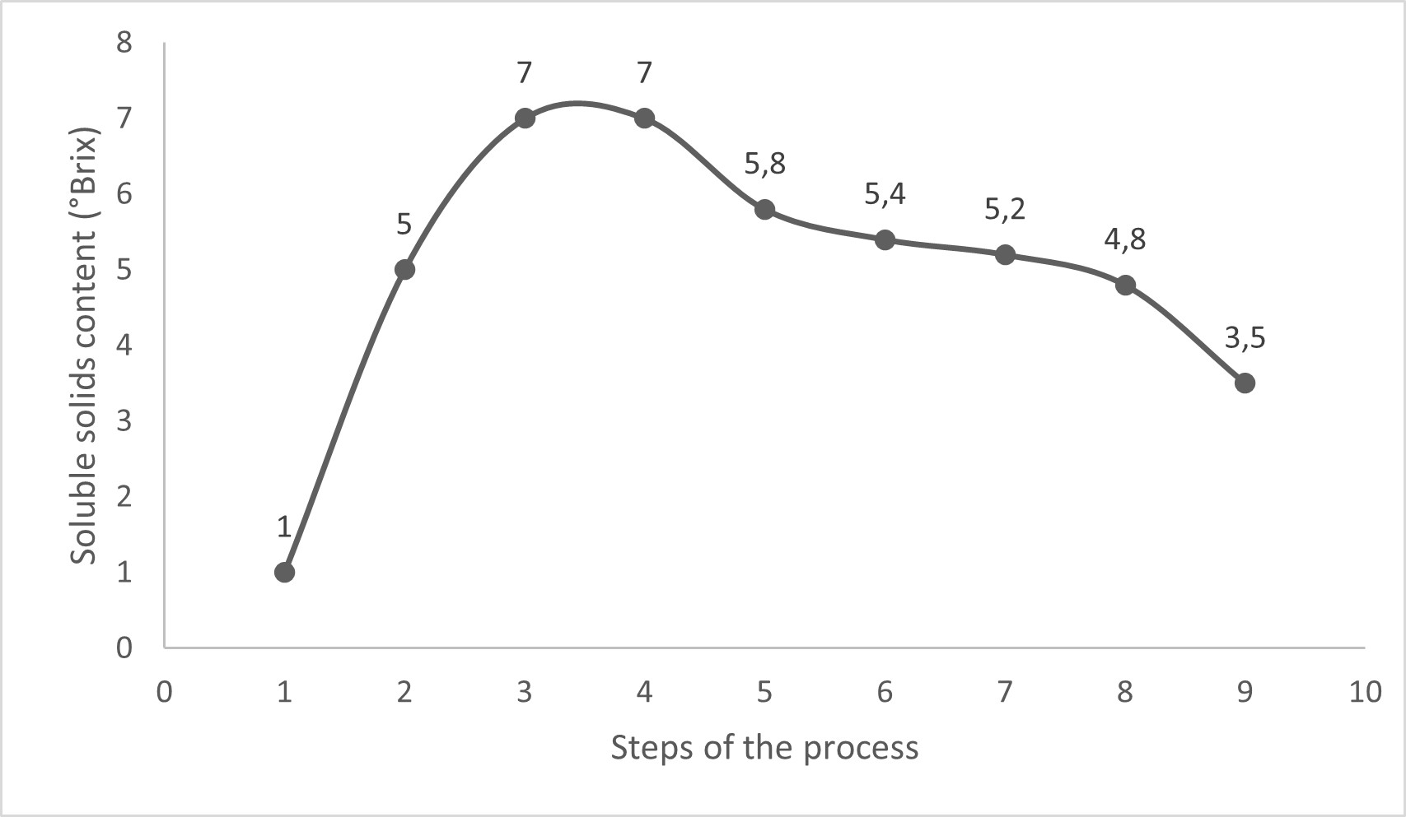
Figure 2: Total soluble solids content (°Bx) during steps of the process to produce yam distillate: 1) Mixing of the ingredients, 2) liquefying, 3) saccharification, 4) Fermentation Day 0, 5) Fermentation Day 1, 6) Fermentation Day 2, 7) Fermentation Day 3, 8) Fermentation Day 4, 9) Fermentation Day 6

Figure 3 presents results obtained for pH, directly in the mash and fermentation tank during all steps. Liquefying process (alpha-amylase) was conduct a pH 5.4 and saccharification was conduct a pH 5.21. At the same pH was started the fermentation process. During the fermentation, pH decreased day until pH 2.7. After 4 step, pH was so low, and probably it can be the cause of low sugars consumption (Narendranath & Power, 2005), because an optimal pH for Saccharomyces cerevisiae is between 4.5 to 5.5. This pH decreasing was probably due to acidification of worth through a combination of proton secretion during nutrient transport (action of the plasma membrane proton-pumping ATPase), production of organic acids (succinate o acetate) dissolution and evolution of the carbon dioxide (Walker & Stewart, 2016), but also probably indicates a bacterial contamination and int is related to a lower ethanol production.

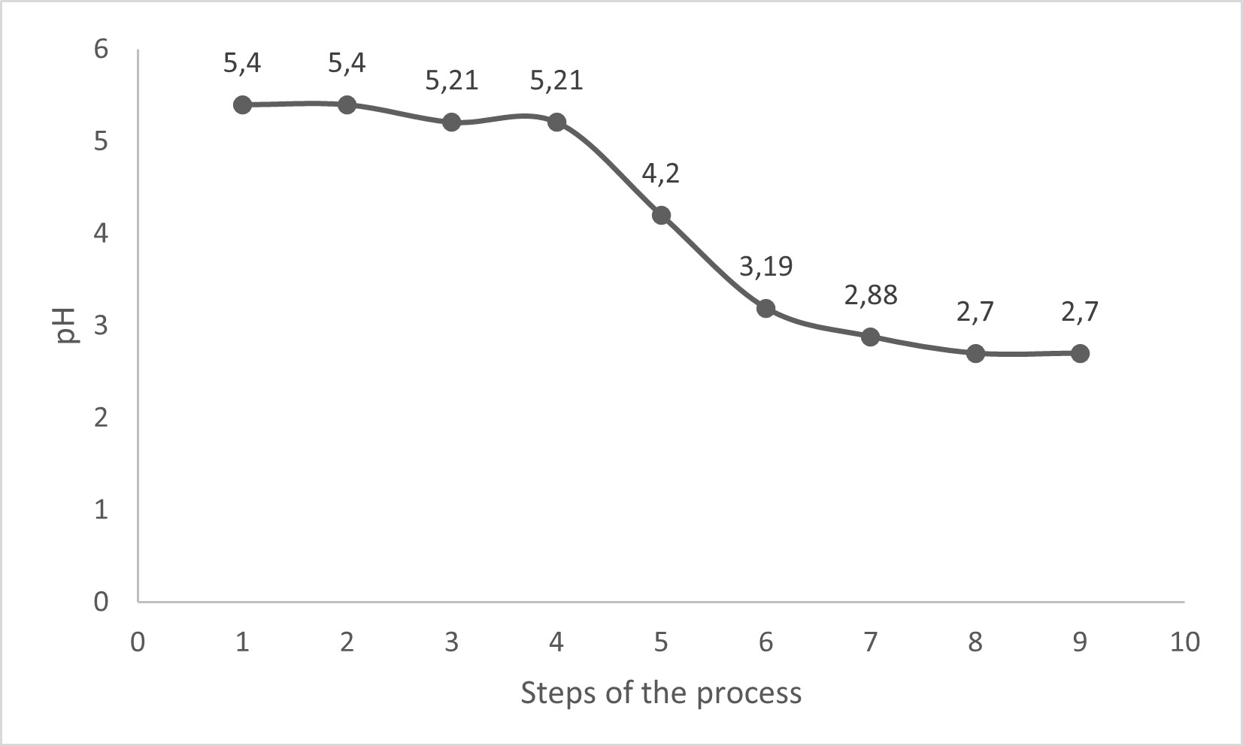
Figure 3: pH during the steps of the process to produce the yam distillate: 1) Mixing of the ingredients, 2) liquefying, 3) saccharification, 4) Fermentation Day 0, 5) Fermentation Day 1, 6) Fermentation Day 2, 7) Fermentation Day 3, 8) Fermentation Day 4, 9) Fermentation Day 6

With Brix degree, specific density, glucose molecular weight and water density at 20 °C was calculated molar glucose consumption. It was supposed that Brix degrees indicated glucose content. Glucose consumption first order kinetics parameters are shown in Table 2. They were calculated with Eq. (4). The R² is 0.94 with represent a good fitting.
Table 2: Parameters for the glucose consumption model
Sample | C_{o} glucose  (M) | k (h⁻¹) |  |  | R²
Yam flour + potatoes starch | 0.38849±0.03800 |  | 0.00442±0.00048 | 0.94

Table 3 shows the parameters for the Gompertz model for ethanol molar concentration and its respective coefficient of determination R², that was 0.88. Parameters a, c and k are related to potential ethanol concentration when times goes to infinite, inflection point and the slope of the curve, respectively. The applied model can be used to predict the behavior of ethanol formation.
Table 3: Parameters for the Gompertz model for the molar concentration of ethanol
Sample | a  (M*h⁻¹) | c  (h) |  | k  (h⁻¹) |  |  | R²adj
Yam flour + potatoes starch | 0.57789 ± 0.344 |  | 68.92 ± 4.689 |  | 0.01261 ± 0.009 | 0.88

Figure 4 shows the behavior of volumetric productivity over time for the trial. It is illustrated that maximum productivity is achieved between 24 and 48 hours of fermentation, and subsequently decreases tending to an asymptotic value.
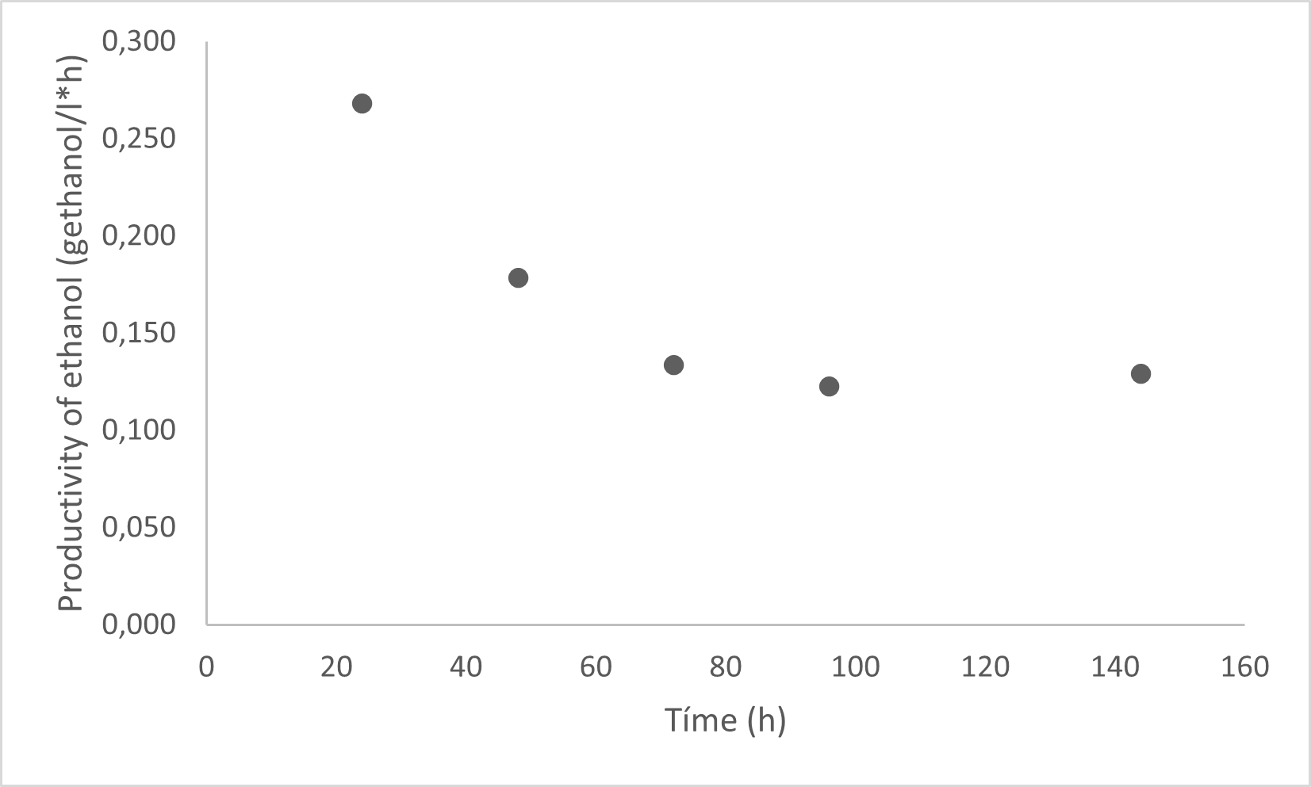

Figure 4: Productivity of ethanol over time for the fermentation of yam flour and potatoes starch wort.
The distillation was done at 70°C, and 400 ml of a distillate was obtained with 80% v/v of ethanol content.
  - Conclusion
It was possible to hydrolyze and ferment a worth with yam flour and potato starch using two commercial enzymes. Initial total content of solids was 7°Bx and after 7 days of fermentation were 3.5°Bx. Low sugars consumption by yeast during fermentation was probably due to worth nutrient deficiency. A first-order kinetics model could be applied to glucose consumption and Gompertz model was applied to ethanol production. Maximal volumetric productivity was reached at 24 hours and a final content of 80%v/v of ethanol was reached in the distillated. So, it was possible to obtain a prelaminar distilled product from yam to prepare a vodka-like beverage by dilution and herbs or fruits addition. It is recommended to increase initial sugars content and adding other materials to supplement worth to improve sugars consumption.
Acknowledgments
The financial support of a project of UNAD (Open and Distance University) code PG2602ECBTI 2022. Special thanks to the Ana Belinda Garcia for the support in the pilot plant lab in headquarters of the UNAD in Bogotá, Colombia.
References
Alvis, A., Vélez, C. A., Villada, H. S., & Rada-Mendoza, M. (2008). Physicochemical and Morphological Analyzes of Yam, Cassava and Potato Starches and Determination of their Viscosity. Información Tecnológica, 19(1), 19–28.
Bieschke, T. (2013). Instruction manual CE-640 Biotechnological Production of Ethanol.
Cano Triana, N. C. (2020). Obtaining fermented alcoholic beverages through standardized processes to strengthen the beekeeper of carmen de bolívar, Bachelor Thesis, University of Cartagena, Cartagena, Colombia
Cuenca, M., Blanco, A., Quicazán, M., & Zuluaga-Domínguez, C. (2022). Optimization and Kinetic Modeling of Honey Fermentation for Laboratory and Pilot-Scale Mead Production. Journal of the American Society of Brewing Chemists, 80(3), 248–257.
D. Polycarp; E. O. Afoakwa; A. S. Budu; E. Otoo. (2012). Characterization of chemical composition and anti-nutritional factors in seven species within the Ghanaian yam (Dioscorea) germplasm. Int. Food Res. J., 19(3), 985–992.
Espitia, J., Salcedo, J., & Garcia, C. (2016). Funtional Properties of Starch Yam (Dioscorea bulbífera,Dioscorea trífida y Dioscorea esculenta). Revista Técnica De La Facultad De Ingeniería. Universidad Del Zulia, 39(1).
González Vega, M. (2012). El ñame (Dioscorea spp.). Characteristics, uses and medicinal value. Important aspects in the development of the crop. Cultivos Tropicales, 33(4), 5–15.
Hurtado, M. G. B. G. B. (2000). Yam: seed production by biotechnology.
Lawrence S. Brown, T. H. (2018). Chemistry for Engineering Students.
Maria de los Angeles Fernandez Haeckermann, Leonardo, J., & Gutiérrez, M. (2012). Evaluation of the lyophilized starch of espino yam (Dioscorea Rotundata) as an exception in the manufacture of eyelash makeup and facial bases. Bachelor Thesis, University of Cartagena, Cartagena, Colombia
Mignouna, B. D., Abdoulaye, T., Alene, A. D., Asiedu, R., & Manyong, V. M. (2014). Characterization of Yam-growing.
Narendranath, N. V., & Power, R. (2005). Relationship between pH and medium dissolved solids in terms of growth and metabolism of lactobacilli and Saccharomyces cerevisiae during ethanol production. Applied and Environmental Microbiology, 71(5), 2239–2243.
Nielsen, S. S. (2007). Food Analysis. (Fourth edicion).
Pradyawong, S., Juneja, A., Bilal Sadiq, M., Noomhorm, A., & Singh, V. (2018). Comparison of cassava starch with corn as a feedstock for bioethanol production. Energies, 11(12), 1–11.
Tejeda Benítez, L., Tejada Tovar, C., Villabona Ortiz, A., Tarón Dunoyer, A., Barrios Mindiola, R., & Malena Tejeda Benítez, L. (2008). Use of the espino yam (Dioscorea rotundata) in the production of bioplastics. Bachelor Thesis, University of Cartagena, Cartagena, Colombia
Walker, G. M., & Stewart, G. G. (2016). Saccharomyces cerevisiae in the production of fermented beverages. Beverages, 2(4), 1–12.

